# How to setup Ardupilot SITL simulation to work with Mission Planner on local Windows computer

# (Running Beagle Systems customized firmware and Mission Planner)

## Requirements

* Windows 10
* VirtualBox 6.12+

## Host Installation (local Windows computer)

1. Install official Mission Planner release on local computer, this will help us config all the path for the program, otherwise we need to config it manually, but since the customized MP is isolate with official version, we can install official version to save some trouble.
2. Download customized Mission Planner from release folder: <https://drive.google.com/drive/folders/1QzaKQNgVLtiXSqfCxxhJXK4zyQrFB-L6>
3. Upzip MIssionPlannerModified_latest.7z to a local folder like “D:\MissionPlannerModified\”
4. Find “MissionPlanner.exe” in the folder and create desktop shortcut for it.
5. Copy everything in this folder: <https://drive.google.com/drive/folders/1cBcQ1XUKk3rROoS1z_mcZ54fWICuCZ5Y>
6. To mission planner config folder, usually it located under: “C:\Users\<username>\Documents\Mission Planner”, this included joystick settings and additional server settings.

Client Installation (Virtualbox VM on local Windows computer)

1. Download Virualbox from <https://www.virtualbox.org/wiki/Downloads>
2. Install VirutalBox as defaults
3. Create a new VM using existed vbox and vdi files:

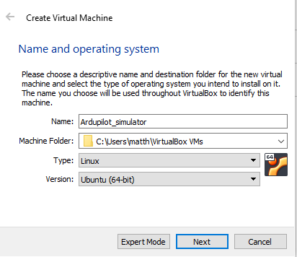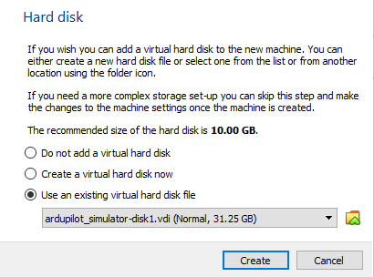

Memory size at least 8GB, CPU core number at least 2 cores.

Set network to “Host-only adapter” in the settings.

1. Start the VM by click on “Ardupilot_simulator” on the left sidebar in VirtualBox manager.
2. All the code and build environment should already be ready to run under folder “~/ardupilot”
3. Check the ip address on both HOST and Client sides, by default:

HOST: 192.168.56.1

Client: 192.168.56.102

1. If the HOST ip is not default, need to change the ip address to “start_simulator.sh”

Open the sh file with GEDITOR and replace with the right IP address.

1. After the client is running, Open up File Explorer on HOST side and in the left pane right-click on “This PC”. Select “Choose a custom network location” and then click “Next”. In “Internet or network address”, enter the address of the Samba share in the following format

“\\<client IP address>\share” (by default is: \\192.168.56.102\share\)

We will use this folder to get log files after simulation.

Usage of Simulator

1. Open client VM in VirtualBox
2. Login to Ubuntu with username “beagle” and password “beagle” if needed
3. Double click “start_simulator.sh” on the Desktop

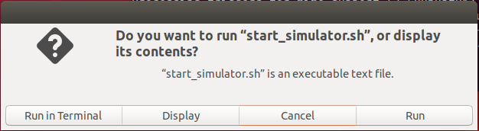

Or open terminal, use the command line: bash ~/Desktop/start_simulator.sh

1. After the simulator is running, open Mission Planner on the HOST side

If the IP address is correct, Mission Planner will be connected automatically.

1. The BIN and tlog file will be generated on the Desktop of Ubuntu.